**Use tables in adobe forms**

1. Go to Tcode SFP .Create an interface and then create a form(For details ,please refer the previous demo)

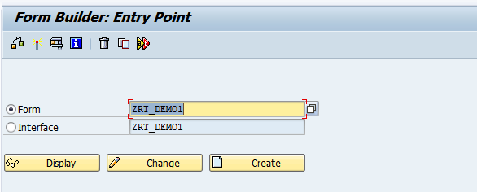

1. Open the interface. In the Import parameter, add the parameter P_CARRID

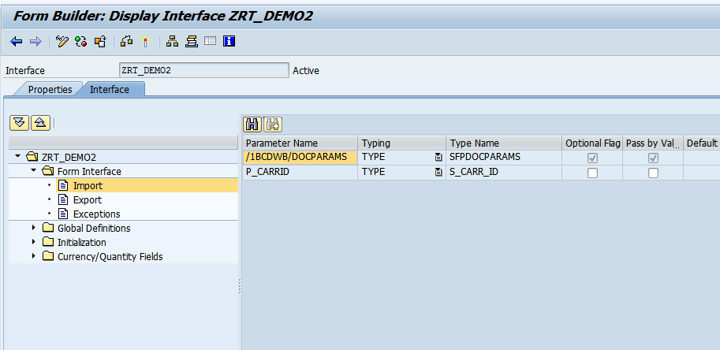

1. In the Global data, declare the internal table IT_SFLIGHT.(Note:Here ZRT_SFLIGHT is table type created in se11)

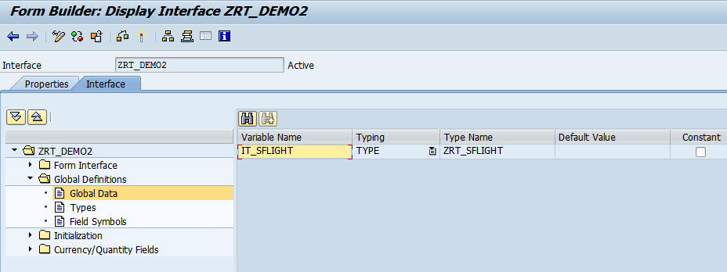 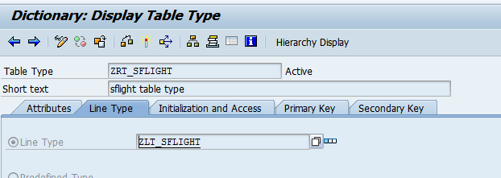

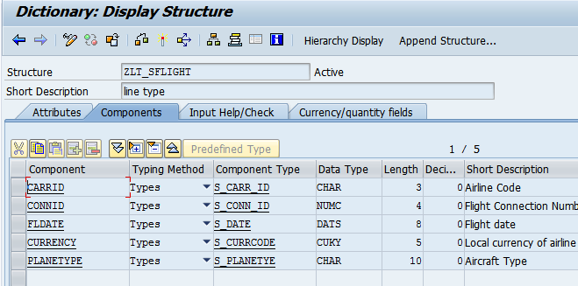

1. Add the below logic in Code Initialisation section

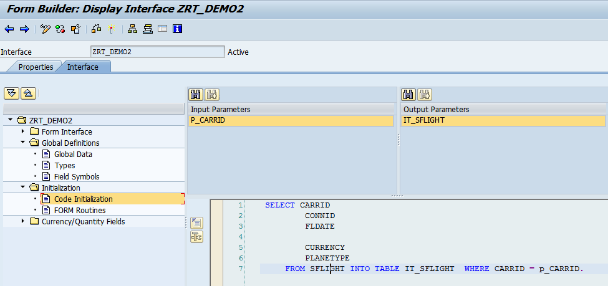

1. Open the Adobe form. Drag and drop P_CARRID and table ITSFLIGHT from Interface section to Context. Then click on Layout

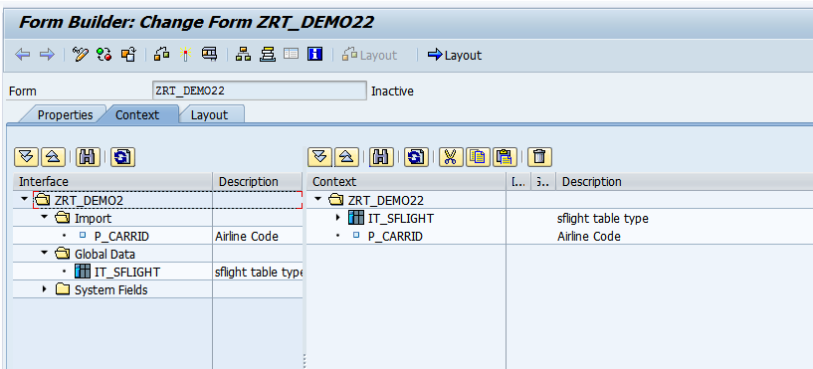

1. In the hierarchy tab, right click on Data-Insert Subform

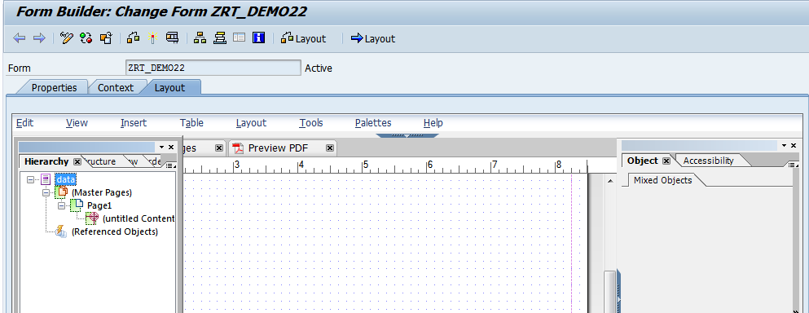

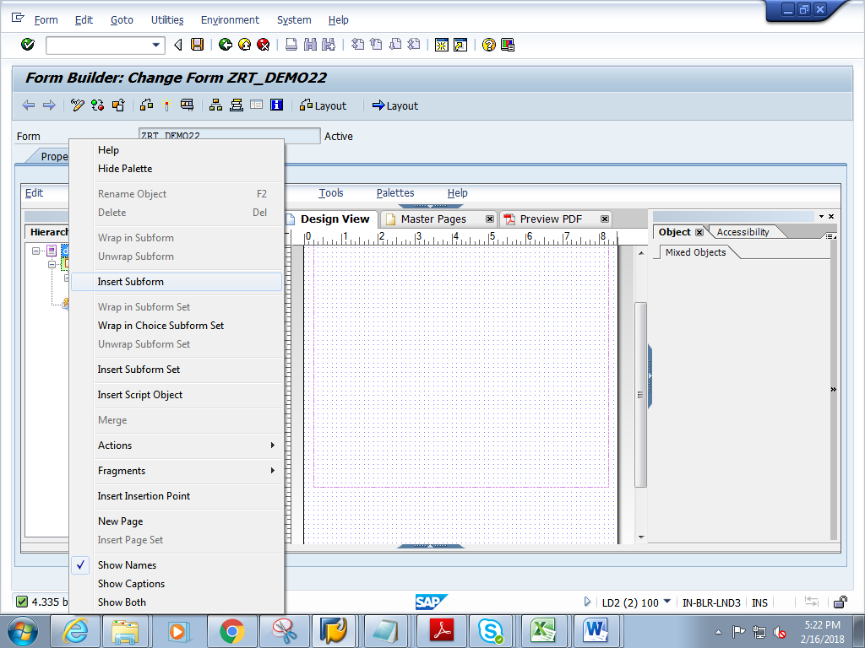

1. Change the name of sub form to Subform1.Resize the form in the design window as required,.

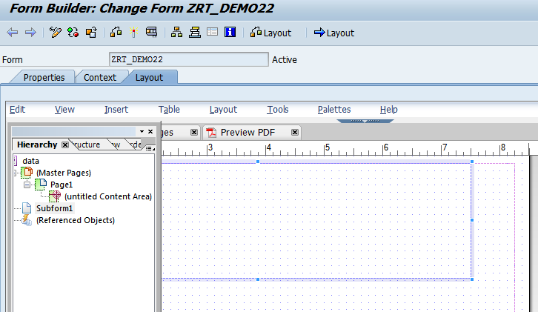

1. From the data view, drag and drop the internal table IT_SFLIGHT into the subform.Make sure the table fits inside the subform dfgsd

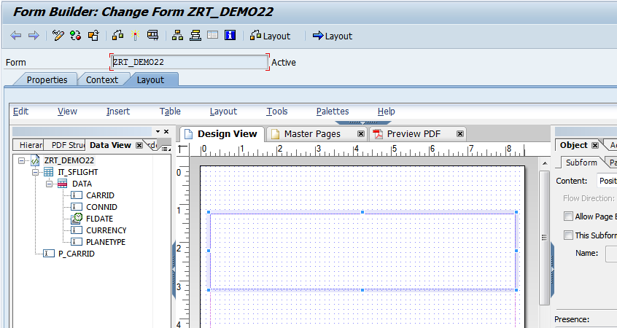

1. Double click on ITS_FLIGHT .The object window of IT_SFLIGHT opens up. **Check on the Allow Pagebreaks with content checkbox**

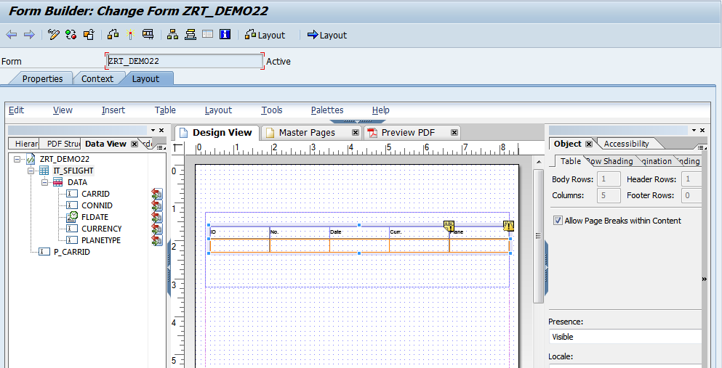

1. In the Hierarchy tab, double click on the Subform1.In the Object window, give the details as shown below.

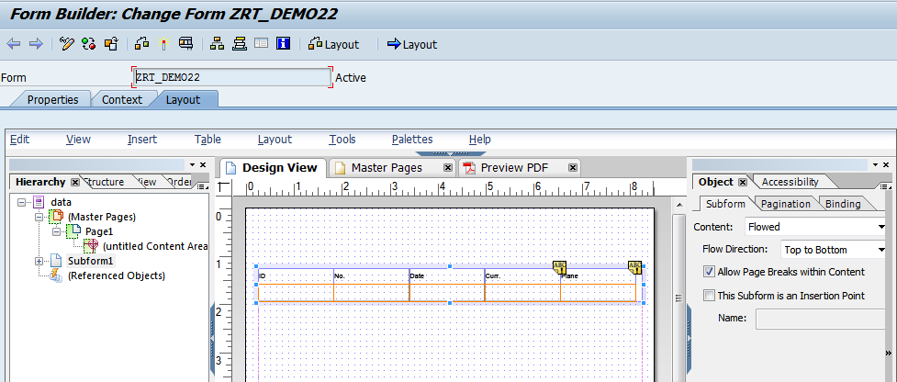

1. Click on context. Save and activate the form
2. Execute the form .Execute the function module

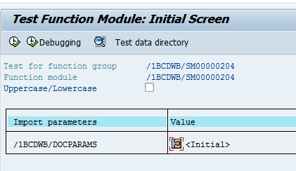

1. Click on Print preview

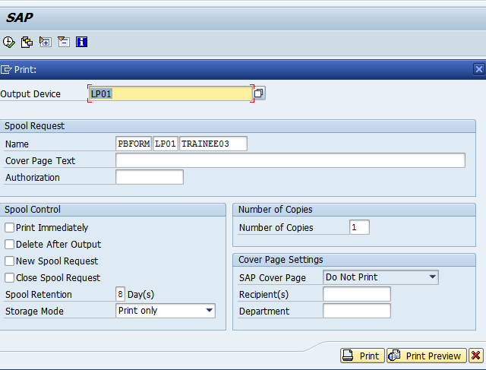

1. Expected output is as follows.

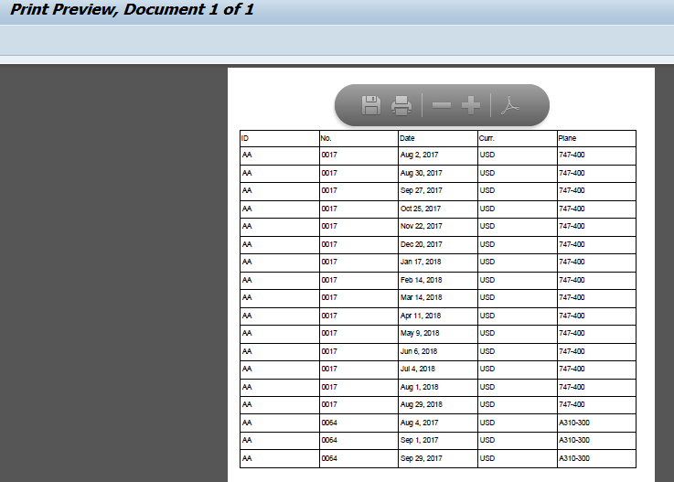

Data flows to the next page succesfuly.

